Ideation Phase
Empathize & Discover

Date | 6 July 2026
Team ID
Project Name | Food Ordering Behaviour and Customer Trends
Maximum Marks | 4 Marks

Empathy Map Canvas:
An empathy map is a simple, easy-to-digest visual that captures knowledge about a user’s behaviours and attitudes.

It is a useful tool to helps teams better understand their users.
Creating an effective solution requires understanding the true problem and the person who is experiencing it. The exercise of creating the map helps participants consider things from the user’s perspective along with his or her goals and challenges.
Example:


Reference: https://www.mural.co/templates/empathy-map-canvas

Example: Food Ordering & Delivery Application
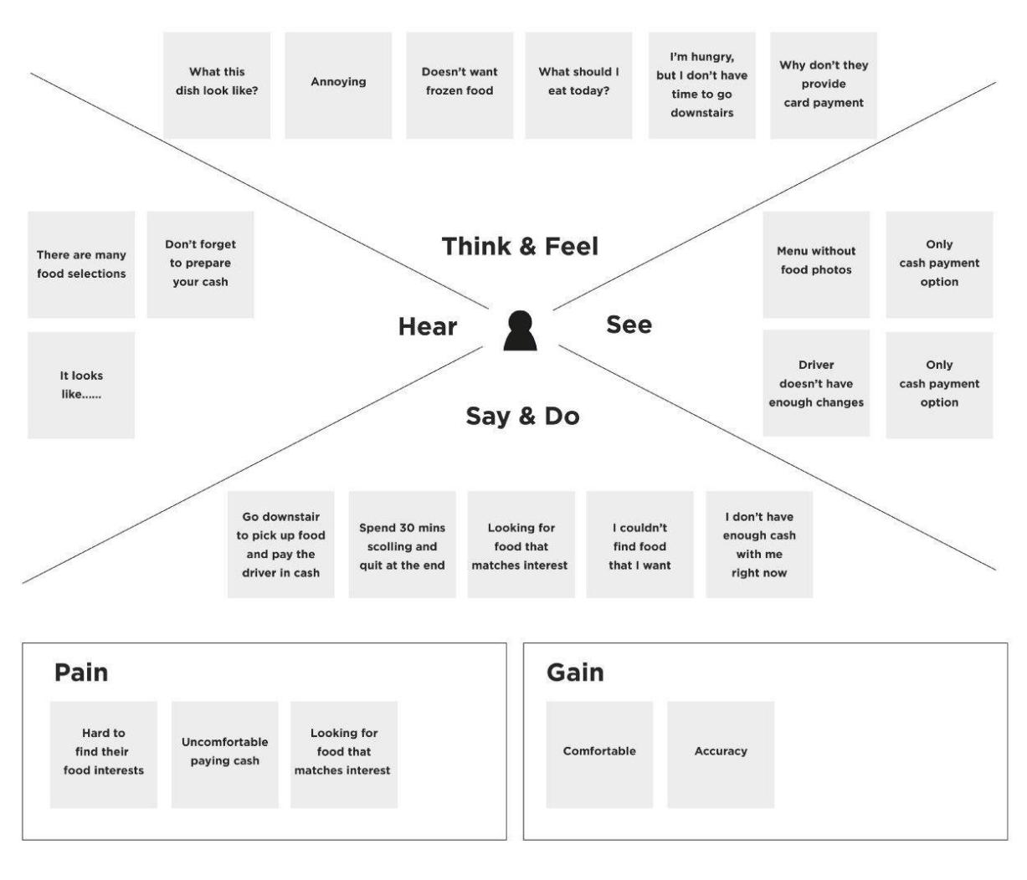

Our Empathy Map Canvas: Food Ordering Application User
Primary user persona: a working professional in a metro city who orders food through mobile or web platforms two to three times a week, balancing convenience, cost and reliability.

THINKS  • Wonders whether the delivery estimate shown on the app will hold up during peak dinner-hour demand.  • Weighs whether a higher-rated restaurant is worth an extra 10-15 minutes of waiting time.  • Questions whether frequent weekday ordering is quietly inflating the monthly food budget.  • Considers switching platforms if the same cuisine keeps arriving late or cold. | SEES  • Sees several restaurants offering similar cuisine with widely different ratings and delivery windows.  • Notices competing discount banners and promo codes crowding the home screen at checkout.  • Observes colleagues and friends sharing food photos and restaurant recommendations online.  • Sees a live tracking map that doesn't always match the rider's actual location.
SAYS  • “I'll only place the order if the delivery time shown is under 30 minutes.”  • “This place has good ratings, but my last order from them still arrived late.”  • “I switch apps depending on which one has the better offer that week.”  • “I only leave a rating when the experience is unusually good or unusually bad.” | DOES  • Compares rating, delivery time and price across two or three apps before confirming an order.  • Applies available coupons and checks free-delivery thresholds before checking out.  • Reorders repeatedly from a short list of trusted restaurants rather than exploring new ones.  • Tracks the rider's live location and contacts support when an order is significantly delayed.
PAINS  • Frustrated when actual delivery time consistently exceeds the estimate shown at checkout.  • Disappointed when food quality or packaging does not match the restaurant's displayed rating.  • Finds it tedious to manually compare multiple platforms for the best price and offer.  • Concerned about hidden charges such as platform fees and surge pricing during peak hours. | GAINS  • Values accurate, transparent delivery windows backed by real-time order tracking.  • Appreciates recommendations personalised to past cuisine preferences and order history.  • Wants confidence that ratings genuinely reflect food quality and delivery reliability.  • Enjoys the convenience of reordering favourite meals in a single tap.

User Needs
• Delivery-time predictions grounded in historical performance data rather than static citywide averages.
• A rating system that reflects both food quality and consistency of delivery service.
• Upfront visibility of total order cost, including fees and applicable discounts, before checkout.
• Cuisine and restaurant recommendations tailored to individual ordering patterns and meal-time habits.

Opportunities
• Use historical order data to refine delivery-time predictions by city, locality and time slot.
• Segment customers by age group and city to design more targeted offers and cuisine recommendations.
• Correlate customer ratings with delivery performance to help restaurants and riders improve service consistency.
• Highlight peak ordering hours and popular meal types to guide restaurant onboarding and inventory planning.

